Assignment 6: upload a static website on s3

1. 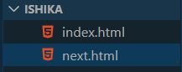Create a folder on the desktop and create 2 html files (index.html, next.html) in that folder.
2. Add an **anchor tag** in both files to go to the other page.

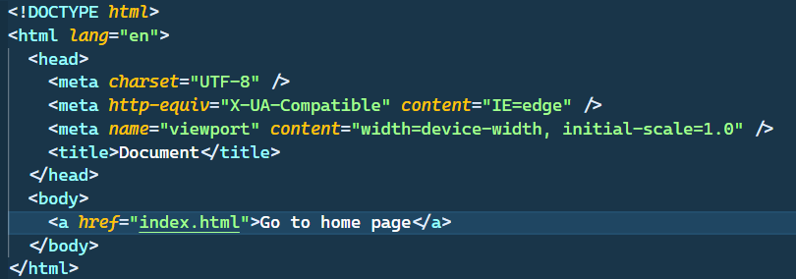

1. Create a **public bucket** (follow the process of assignment 5) in s3.
2. 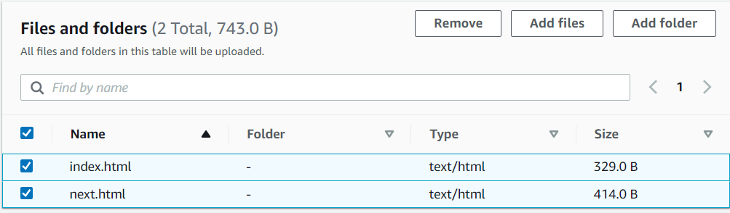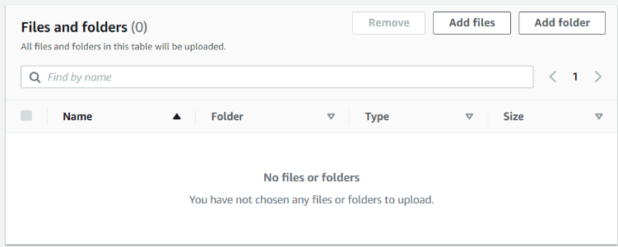go into that **bucket** and click **upload files** choose two files made on the desktop.
3. 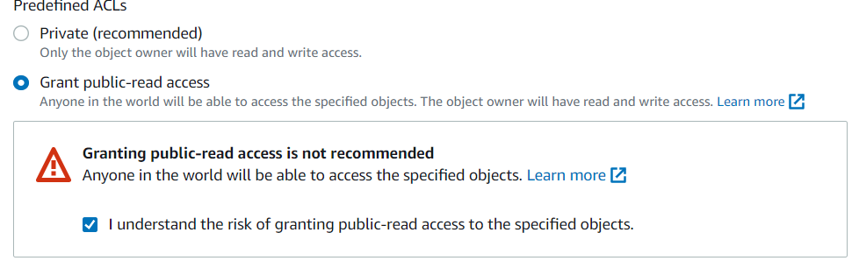Go down to **permissions** and check **grant public read access** then check **I understand** and click **upload.**
4. Two files will appear in your bucket then go to properties and go to the static website hosting then click **edit** check hosting **enable.**

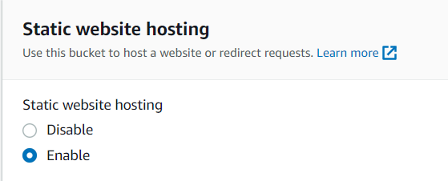

1. 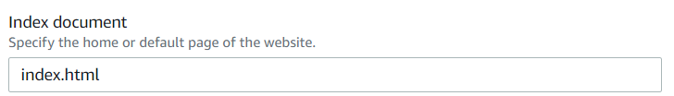In the field Index document write the main file name **index.html** then **save changes.**
2. 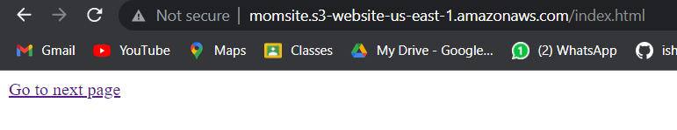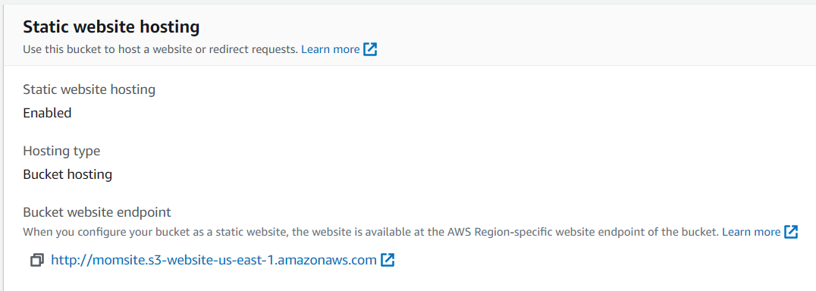Copy the **static website hosting URL**, paste it to a different browser, and see if the page is coming.

